Haul-out behavior and aerial survey detectability of seals in the Bering and Chukchi seas

Josh M. London1,✉, Paul B. Conn1, Stacie K. Hardy1, Erin L. Richmond1, Jay M. Ver Hoef1, Michael F. Cameron1, Justin Crawford2, Andrew L. Von Duyke3, Lori T. Quakenbush2, and Peter L. Boveng1

1 Marine Mammal Laboratory, Alaska Fisheries Science Center, NOAA Fisheries, Seattle, Washington, USA  
2 Arctic Marine Mammals Program, Alaska Department of Fish and Game, Fairbanks, Alaska, USA  
3 Department of Wildlife Management, North Slope Borough, Utqiaġvik, Alaska, USA

✉ Correspondence: [Josh M. London <[josh.london@noaa.gov](mailto:josh.london@noaa.gov)>](mailto:josh.london@noaa.gov)

## Abstract

Ice-associated seals rely on sea ice for a variety of activities, including breeding, molting, pupping, and resting. In the Arctic, many of these activities occur in spring (April-June) as sea ice begins to melt and retreat northward. Rapid acceleration of climate change in Arctic ecosystems is therefore of concern as the quantity and quality of suitable habitat is forecast to decrease. In this paper, we use data collected from satellite-linked bio-loggers deployed between 2005 and 2020 to investigate the seasonal timing and environmental factors affecting haul-out behavior by ice-associated seals. We specifically focused on bearded (*Erignathus barbatus*), ribbon (*Histriophoca fasciata*), and spotted seals (*Phoca largha*)) in the Bering and Chukchi seas. Because ringed seals (*Phoca hispida*) are unique in their use of snow lairs, they were not included and a separate analysis is warranted. In addition to providing baseline data on phenology, these data also allow us to quantify ‘availability’, which is needed to accurately estimate abundance from aerial survey counts of these seals basking on ice (i.e., to correct for the proportion of animals that are in the water while surveys are conducted). Using generalized linear mixed pseudo-models to properly account for temporal autocorrelation, we fit models with covariates of interest (e.g., day-of-year, solar hour, age-sex class, wind speed, barometric pressure, temperature, precipitation) to examine their ability to explain variation in hourly haul-out probability. We found evidence for strong diurnal and within-season patterns in haul-out behavior, as well as strong weather effects (particularly wind and temperature). In general, seals were more likely to haul out on ice in the middle of the day and when wind speed was low and temperatures were higher. Haul-out probability increased through March and April, peaking in May and early June before declining again. The timing and frequency of haul-out events also varied based on species and age-sex class. For ribbon and spotted seals, models with year effects were highly supported, indicating that the timing and magnitude of haul-out behavior varied among years. However, we did not find evidence that haul-out timing was linked to annual sea ice extent. Our analysis emphasizes the importance of accounting for seasonal and temporal variation in haul-out behavior, as well as associated environmental covariates, when interpreting the number of seals counted in aerial surveys.

keywords: availability; generalized linear mixed pseudo-model; haul-out behavior; phenology; Phocidae; sea ice

# Introduction

The global climate disruption is causing considerable reduction in Arctic sea ice extent, volume, and seasonal presence [1–4]. These changes have ripple effects on Arctic organisms, ecosystems, and the human communities who live in the region [5]. Such disruptions are a particular cause of concern for the ice-associated seals that depend on spring and early summer sea ice (March-June) in the Bering and Chukchi seas as a platform for important life history functions, such as pupping, nursing, breeding, and molting [6–9]. Limited data and large knowledge gaps complicate predictions about the ultimate effects of changes in sea ice on the behavior, health, abundance, and distribution of these seals. To date, indices of seal health sampled during periods of declining sea ice differ regionally [10,11]. Knowledge about evolutionary constraints on the timing of reproductive and molting behavior is generally lacking, so it is difficult to predict the readiness with which ice-associated seal species will be able to adapt to future changes (e.g., by adjusting pupping or molting schedules to earlier dates or different locales). This is further complicated by the spatio-temporal variation in the phenology of these life history events within regions and throughout their full ranges. Additionally, trends in abundance from large scale surveys of these species are unknown, so it is difficult to assess the effect, if any, declines in sea ice habitat have had, or will have, on seal densities.

For ice-associated seals, haul-out behavior is tightly linked with sea ice. Ribbon seals (*Histriophoca fasciata*) haul out of the water almost exclusively on sea ice and are mostly pelagic outside the spring pupping, breeding, and molting season [12]. While spotted (*Phoca largha*) and bearded (*Erignathus barbatus*) seals rest on coastal features, they strongly prefer sea ice as a resting platform during the spring and early summer [13]. Ringed seals (*Phoca hispida*) — not included in this study — bask on sea-ice but also within snow lairs built during the spring. The remoteness of the Bering and Chukchi seas mean direct scientific observation of seal behavior is impractical. Thus, bio-logging devices are especially useful tools for collecting key information on movement and haul-out behavior for these species.

Bio-logging records of time spent out of the water provide valuable data for identifying covariates that explain variation in haul-out behavior. For instance, in the Antarctic, Bengtson and Cameron [14] relied on bio-logging data to demonstrate greater haul-out propensity in juvenile crabeater seals (*Lobodon carcinophaga*) than adults, with highest probabilities in February and at times close to solar noon. In the Arctic, Von Duyke et al. [15] used satellite-linked bio-loggers to corroborate seasonal changes between diurnal and nocturnal haul-out behavior of ringed seals previously described by Kelly et al. [9] using VHF radio tags and direct observation. Bengtson et al. [16] documented a higher propensity for ringed seal basking near solar noon, as did Ver Hoef et al. [17] in an analysis of bearded, ribbon, and spotted seals using much larger sample sizes. Olnes et al. [18] showed that the proportion of time bearded seals spent hauled out progressively increased through spring and summer. And, Ver Hoef et al. [17] found haul-out probabilities increased gradually starting in March and peaking in May and June for bearded, ribbon, and spotted seals.

Knowledge of haul-out patterns is not only important for understanding natural history and ecology, but also for developing “availability” correction factors for aerial surveys. Specifically, researchers need to know the fraction of seals hauled out (versus in the water) when aerial surveys are conducted. Studies estimating availability correction factors for seals typically use logistic regression-style analyses to estimate the time-specific probability of being hauled out based on ‘wet/dry’ data relayed by bio-loggers. In these models, haul-out probabilities were expressed as a function of predictive covariates, such as time-of-day, day-of-year, sex, age class, and environmental conditions (e.g., [19], [14], [16], [20], [17], and [21]). However, sample sizes have often been insufficient to permit strong inference about life history and/or seasonal variation in haul-out probabilities. For instance, Bengtson and Cameron’s [14] study included 5 adult and 2 juvenile crabeater seals, while Bengtson et al.’s [16] study was based on 6 ringed seals in the Chukchi Sea. These studies were often further limited by logistical constraints on fieldwork and the attachment duration or operational life of bio-loggers. In this study, we address some of these limitations by deploying small bio-loggers designed for longer-term attachment on rear flippers of a subset of the study individuals. These devices are designed to collect data through the molt period (when those adhered to the hair would fall off) and, in some situations, provide multiple years of data.

Ultimately, knowledge of trends in phenology and abundance (or life history surrogates such as survival and recruitment) will be necessary to make credible quantitative predictions about the effects of climate disruptions on the abundance and distribution of Arctic seal populations. Before we can construct a trend, however, we first require a baseline. Several studies have contributed estimates of the distribution and abundance of ice-associated seal species in the Arctic using aerial surveys (e.g., [16], [22], and [17]). Such abundance studies were conducted over very large areas and estimation of absolute abundance required making inference about numerous issues affecting the observation of seals on ice. These included availability (only seals basking on ice were available to be counted), detection probability (observers or automated detection systems may have missed some seals on ice), species misclassification, and possible disturbance of seals by aircraft [17,22]. Refining these inferences will improve the accuracy of abundance estimates in the Arctic.

In this study, we used 16 years of bio-logging data to investigate the haul-out behavior of bearded, ribbon, and spotted seals in the Bering and Chukchi seas. Our goals were threefold. First, we wished to establish baseline estimates for the chronology of haul-out behavior in the critical spring season for each species across different age and sex classes. Second, we refined estimates of haul-out availability corrections for aerial surveys in order to improve estimates of seal abundance. Previously estimated availability correction factors (e.g., [16], [22], and [17]) accounted for variables such as the time-of-day and day-of-year, but did not investigate meteorological variables that have been shown to influence haul-out behavior of walruses [19,20]. Third, we assessed the annual variability in haul-out timing and possible linkage to changes in the extent of seasonal sea ice between 2005 and 2020. Our work extends the scope of previous haul-out analyses, includes the influence of meteorological variability, and investigates the potential impact of a changing icescape on the behavior of these species.

# Methods

## Data collection

Data used in our study came from bio-loggers deployed on bearded, ribbon, and spotted seals in the Bering, Chukchi, and Beaufort seas by multiple organizations as part of collaborative investigations from 2005 through 2020. Seals were captured using nets and bio-loggers attached during ship-based capture trips and from coastal Alaska communities. Ship-based capture events occurred during spring near the southern ice edge in the Bering Sea. Land-based capture events occurred from May to October, generally between the coastal communities of Scammon Bay, Alaska, in the Bering Sea, and Utqiaġvik, Alaska, near the junction of the Chukchi and Beaufort seas, from 2005 to 2020. We refer readers to the primary literature for detailed capture and bio-logger attachment methods (Supplemental Material, Table).

Haul-out behavior data from bio-loggers deployed on 249 bearded, ribbon, and spotted seals were subset to include only records from 1 March to 15 July between 2005 and 2020. Bio-loggers were of the ‘SPLASH’ or ‘SPOT’ family of tags developed by Wildlife Computers (Redmond, Washington, USA) and either adhered to the hair on the seal or attached to the rear flipper inter-digital webbing. The use of bio-loggers adhered to the back or head provide some benefits over flipper mounted devices (e.g. increased satellite transmittal rates, locations at sea) but these are lost during the following annual molt, which, depending on deployment date, limits the duration of haul-out data they provide. Additionally, bio-loggers attached to the head or dorsal region are often dry while the seal is at the surface and can slightly bias the hourly percent-dry values reported by the bio-logger. For this study, in cases where both bio-logger types were deployed, hourly percent dry observations from the flipper tag were preferred.

Field identification of age class can be inexact, particularly when discerning subadults from adults. Sex and age class (non-dependent *young-of-the-year*, sexually immature *subadults*, and mature *adults*) were estimated at the time of deployment by various combinations of length, claw growth ridges [23–25], and pelage characteristics for some species. In the case of ribbon seals, subadults often have less distinct ribbons than adults. Bearded seal subadults will often have a spotted pattern in the pelage that is not seen in adults. Spotted seal pelage cannot be used to reliably discern adults from subadults. Despite these challenges, we feel the age classifications used in this analysis are useful in testing for age-related effects on haul-out behavior. Seals determined to be less than one year were classified as young-of-the-year. Subadults are those seals likely greater than one year of age but not yet sexually mature. Adults are likely sexually mature and older than four years. For those bio-loggers deployed on young-of-the-year and transmitting into the next year, the age class was advanced to subadult on 1 March of the following year. Table provides a summary of these deployments and data received from them.

|  | | Age Class | | |
| --- | --- | --- | --- | --- |
| Species | Sex | Adult | Subadult | Young-of-the-Year |
| Bearded seal | F | 1 ( 1,776 seal hours) | 16 (21,648 seal hours) |  |
| Bearded seal | M | 2 ( 1,676 seal hours) | 16 (17,232 seal hours) |  |
| Ribbon seal | F | 33 (35,128 seal hours) | 18 (15,984 seal hours) | 13 ( 3,734 seal hours) |
| Ribbon seal | M | 24 (27,465 seal hours) | 19 (13,046 seal hours) | 9 ( 4,275 seal hours) |
| Spotted seal | F | 23 (20,654 seal hours) | 20 (17,542 seal hours) | 11 (13,417 seal hours) |
| Spotted seal | M | 20 (28,360 seal hours) | 21 (17,210 seal hours) | 12 (11,285 seal hours) |

**Table** : Summary of bio-logger data across seal species and age classification from 1 March to 15 July 2005-2020. Total seal hours represents the sum of available data across all seals. Because young-of-the-year are advanced to subadult on 1 March of the following year, some individual seals are represented in both columns in this table

Tags that fall off due to molt, attachment failure, or seal mortality and remain on ice or land can still send data to satellites; i.e., the bio-logger will be on ice or land and dry, therefore, it will record and transmit data suggesting the seal is hauled out. As such, end times of each deployment were identified by examining bio-logger locations and dive behavior to determine when bio-loggers ceased providing data consistent with seal behavior. Data outside of the deployment start and end times were discarded prior to analysis. After approximately 9 months, 7 devices deployed on the rear flipper of bearded seals reported implausible hourly percent-dry data. All data after the first instance of unrealistic values were censored from this analysis. Figure shows the distribution of all haul-out data across the study season for each species. Observations for ribbon and spotted seals are concentrated in the months of May and June due to the timing of deployment (April and May) and the timing of molt (May and June). During molt, seals (and their attached bio-loggers) spend more time out of the water and more data are transmitted. Molt timing also impacts when many deployments end as any bio-loggers adhered to the hair will fall off. Bearded seal deployments are more evenly spread with fewer observations in May and June. The majority of bearded seal deployments start later in the summer and by May bio-loggers have either fallen off or the batteries are depleted.

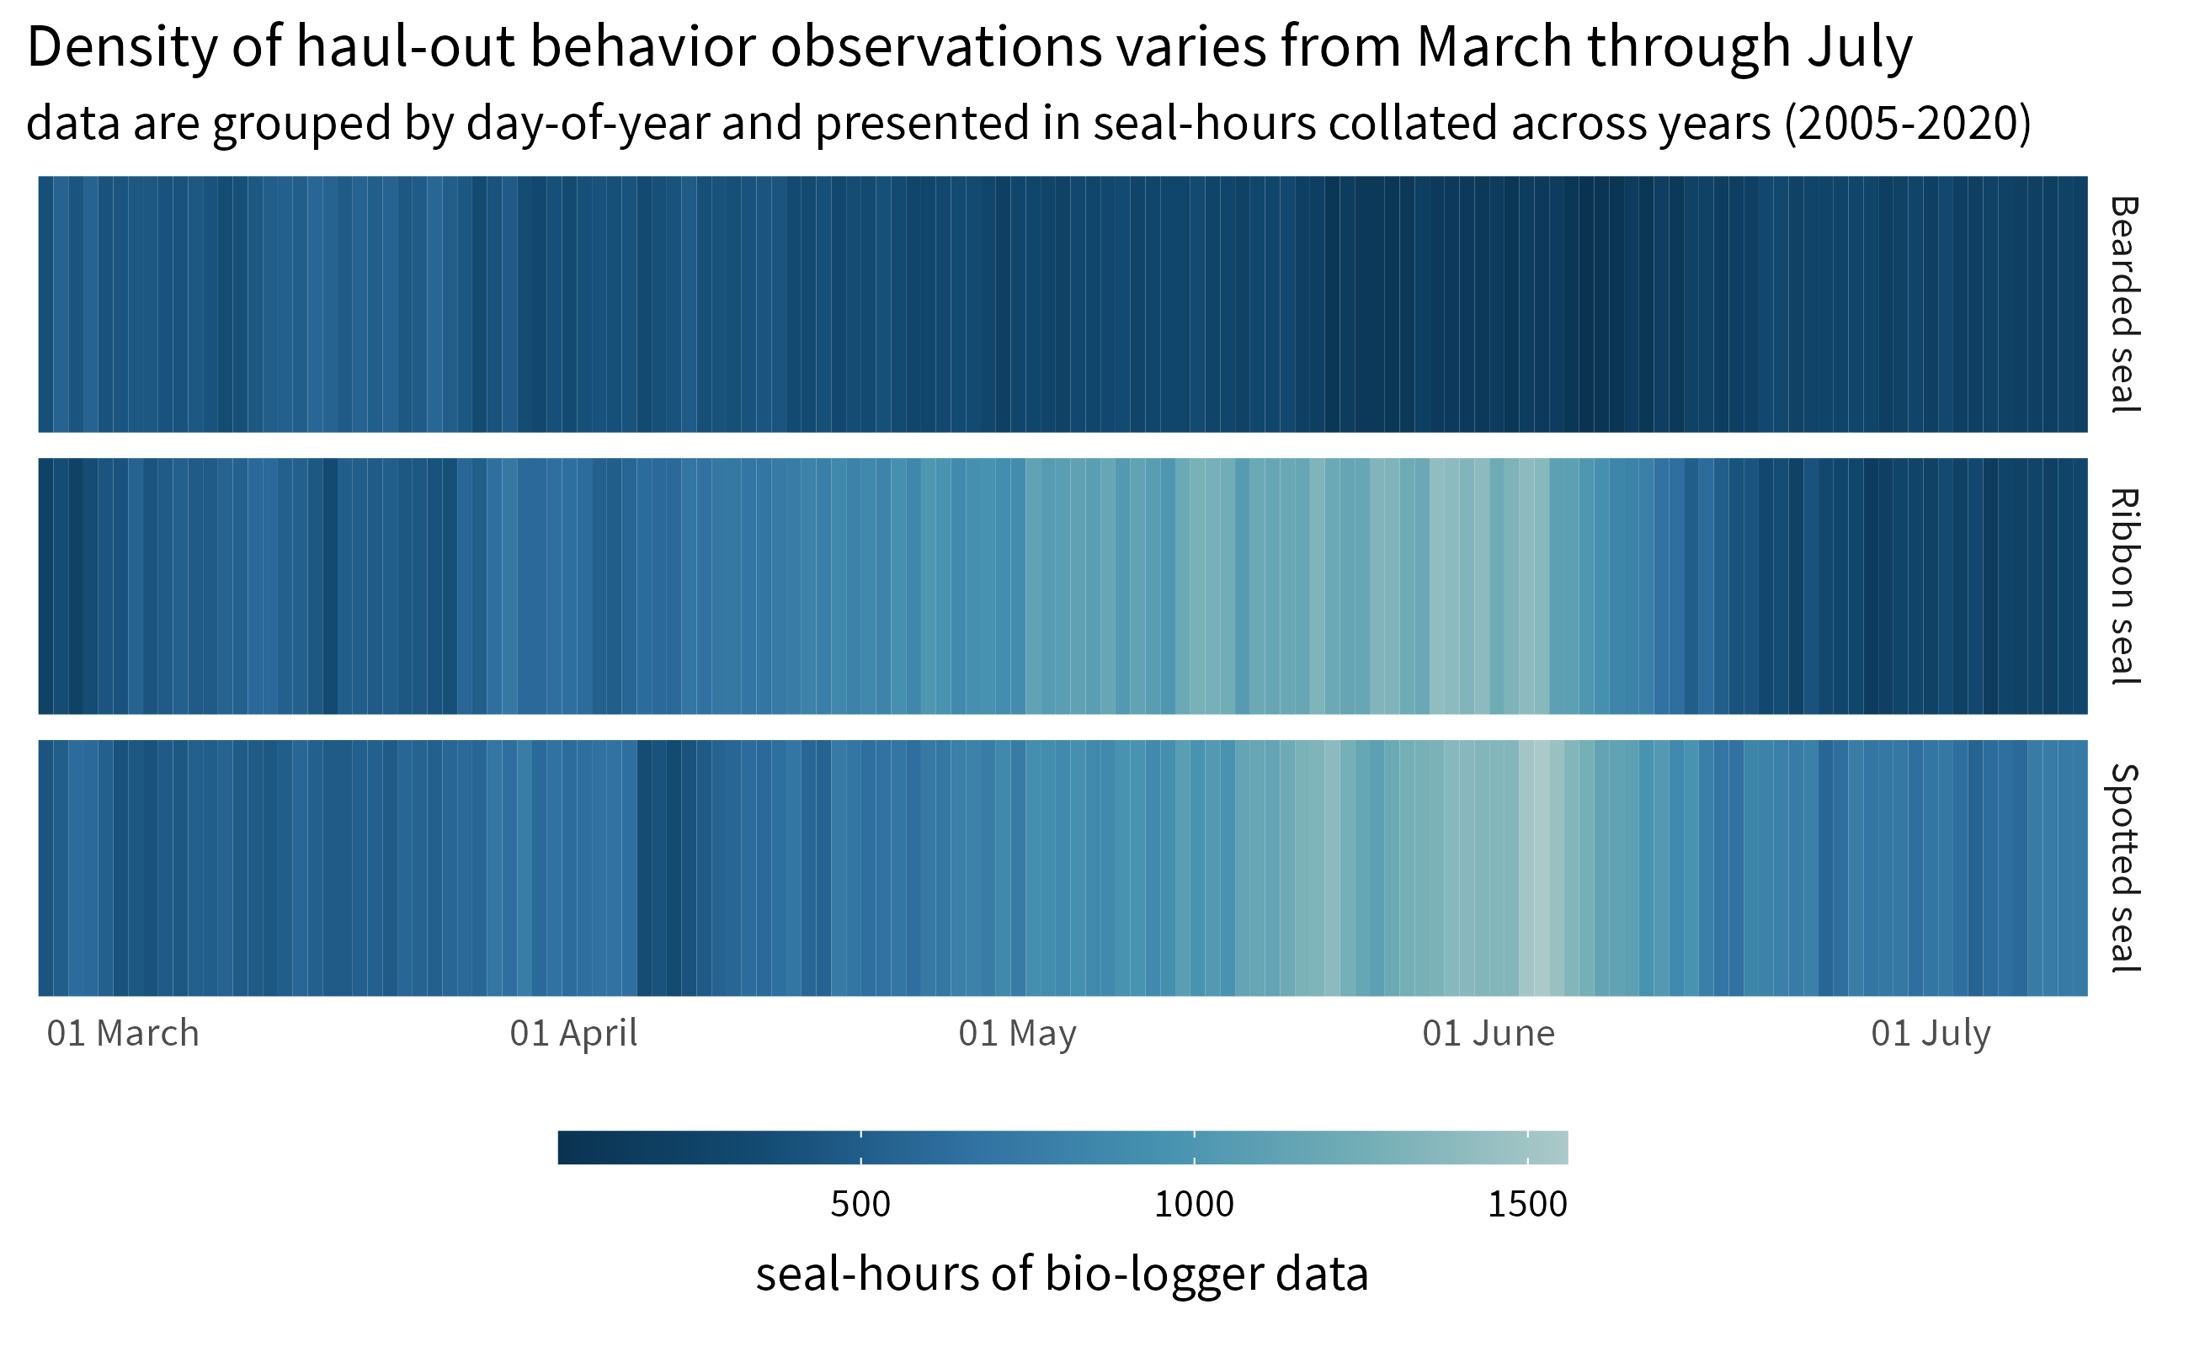

**Figure** : Distribution of hourly percent-dry bio-logger data from 1 March to 15 July for each species. Data are grouped by day-of-year and presented in seal-hours collated across all years between 2005 and 2020. The higher density of data from May and June in ribbon and spotted seals coincides with peak molting when seals (and their attached bio-loggers) are more likely hauled out. Additionally, many bio-logger deployments started in April and May.

Haul-out behavior data were recorded and transmitted via the Argos satellite network as hourly percent-dry timelines. For each hour of a day, the wet/dry sensor was polled by the tag firmware every few seconds and a percent of the hour in a dry state was calculated (Figure ). On board the bio-logger, hourly percent-dry data were rounded to the nearest 10 percent inclusive of 0 and 100 percent and additional values at 3 and 98 percent. This compression resulted in additional data transmission as each message consisted of two complete 24-hour records. Bio-loggers were, generally, deployed and programmed in a manner to maximize data transmission during the spring pupping and molting period; however, hourly percent-dry data were not always successfully transmitted. This is due to a variety of factors including satellite coverage, tag availability (i.e. tags mounted to the rear flipper often do not transmit while at sea), tag performance, duty cycling, and extra-terrestrial atmospheric interference. Fortunately, missing records do not seem to greatly bias inference about haul-out probabilities [26].

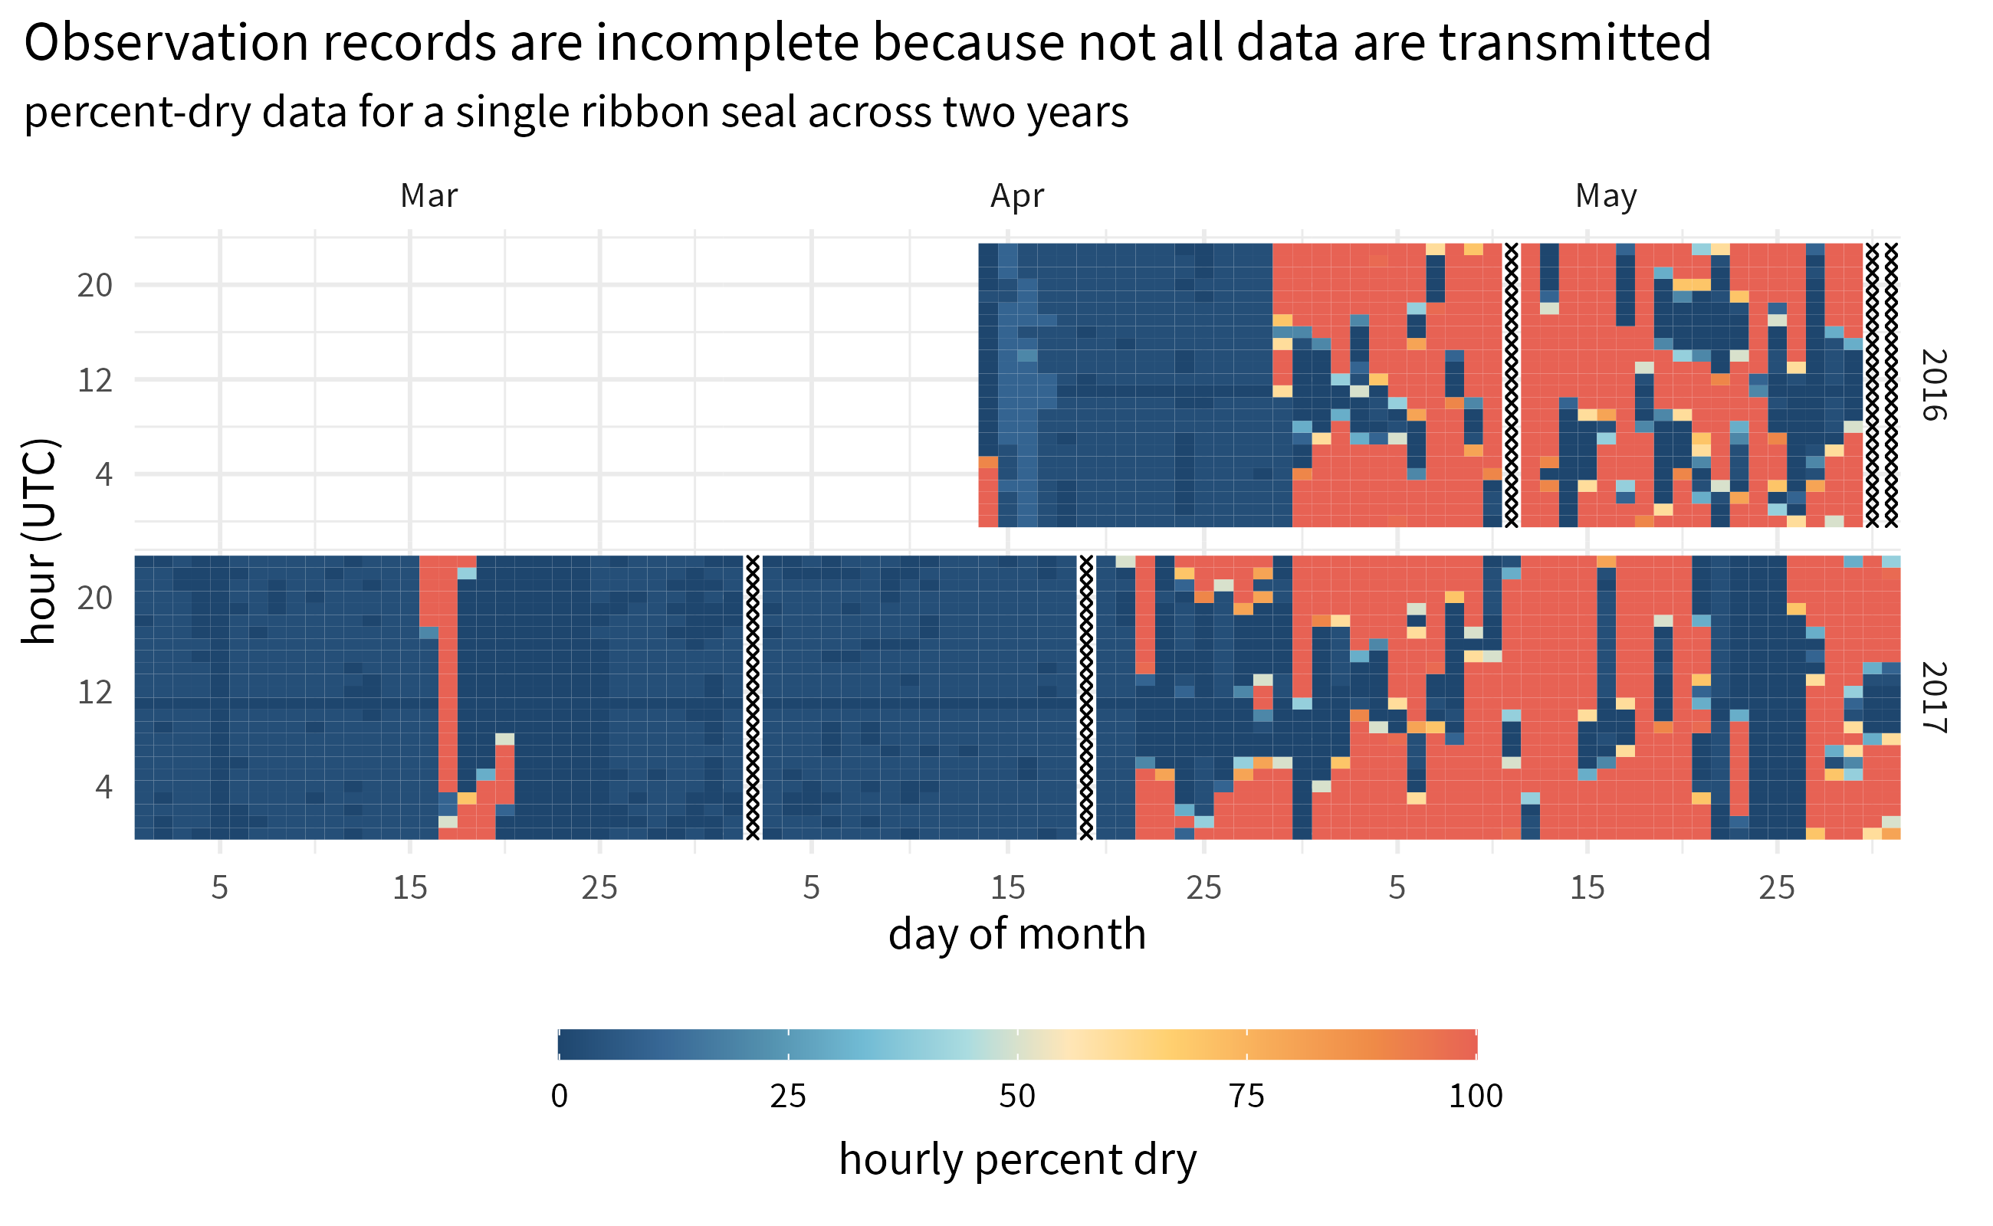

**Figure** : Haul-out behavior observations recorded by a bio-logger deployment on a ribbon seal over two years during the months of March, April, and May. Areas of the plot indicated with an ‘X’ represent missing data that were not successfully transmitted from the tag.

Of key interest in this study was the relationship between haul-out behavior and weather covariates that vary with time and animal location. We explored the use of a continuous-time correlated random walk [27] movement model to predict locations at specific times. However, the sparse nature of data from some bio-loggers, especially those mounted to the rear flipper, resulted in poor modeling performance or convergence issues. For this study, we calculated a weighted average daily location where the inverse of the estimated Argos or FastLoc GPS location error was used for the weight. Each Argos location estimate was assigned an error radius based on either the categorical location quality ( *3*=250m, *2*=500m, *1*=1500m, *0*=2500m [28]; we chose 2500m for location classes *A* and *B*) or, when available, the estimated error radius from the Argos Kalman filter algorithm. Location estimates from FastLoc GPS were all assigned an error radius of 50m. Any days where haul-out observations were present but location data were missing we used the last calculated weighted average daily location, and any days where the location intersected with land were removed from the data set. We recognized that bearded and spotted seals haul out on land. However, assessing the relationship between haul-out behavior and weather covariates and their availability for aerial surveys on land was outside the scope of this study. Additionally, any daily locations on land are likely more reflective of coordinate averaging and measurement error instead of actual use of coastal features. Figure shows the spatial distribution weighted locations with available haul-out behavior data for each species across the study area.

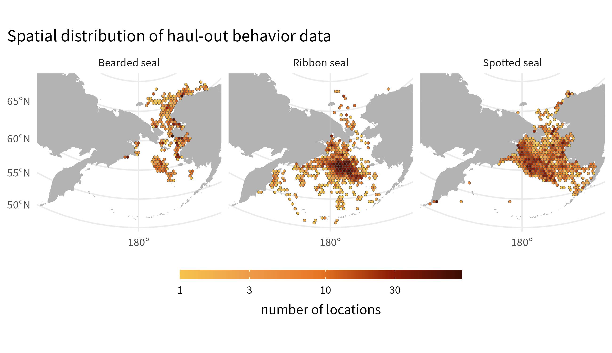

**Figure** : Spatial distribution of haul-out data during the months of March through July 15 for each of the three species. Data were collated across all years between 2005 and 2020.

## Explanatory variables

In addition to sex and age class, we analyzed variables that might help explain variation in haul-out probabilities. These included day-of-year (for seasonal effects) and local solar hour (for diurnal effects). Solar hour was calculated using the {solaR} package [29] within the R statistical environment [30] using the daily locations. We included several weather variables shown to affect haul-out behavior in other Arctic pinnipeds [19,20,31]. In particular, we linked the weighted average daily locations from our bio-loggers to key weather values from the North American Regional Reanalysis (NARR) model produced by the National Centers for Environmental Prediction [32]. The NARR model assimilates observational data to produce a long-term picture of weather over North America. Numerous weather variables are made available across the region 8 times daily. For this study, NARR weather values were subset to the extent of our study area over the Bering and Chukchi seas at 3-hr intervals based on the native grid resolution of 32 km (1024 sq. km). The following meteorological variables were interpolated and assigned to seal locations using a bilinear method: 1) air temperature at 2m above the earth’s surface, 2) wind consisting of northerly and easterly vector components converted to wind speed using the Euclidean norm, 3) barometric pressure at sea level, and 4) precipitation (Table ).

Models for all species include the following effects: day-of-year, solar hour, temperature, wind speed, barometric pressure, precipitation, wind chill (represented by a *wind:temperature* interaction [20]), and day-of-year and time-of-day (solar hour) interactions to permit diurnal patterns to change from March to July. Ribbon and spotted seal models included age-sex class and interactions between day-of-year and age-sex class, but we omitted these from bearded seal models due to poor representation of age-sex classes (Table ). Bearded seal models included a latitudinal effect (and an interaction with day-of-year), since bearded seals occupy a substantial range and we were interested in possible differences in the timing of haul-out behavior along a latitudinal gradient. We omitted the latitudinal effect from ribbon and spotted seal models since, during the spring, these species are most prevalent near the southern ice edge in the Bering Sea [22].

Notably missing from this list of explanatory variables is any spatial-temporal representation of sea ice concentration, area, or extent. This may seem counterintuitive when modeling the haul-out behavior of seal species with such a close association to sea ice; seals haul out in the presence of sea ice, and we could assess the local concentration of sea ice during these events (see [18]). However, a major focus of this study is to develop models applicable for aerial survey correction factors and using sea ice as a covariate would almost certainly bias haul-out predictions towards those seals that are on or near ice and therefore more likely to haul out. Since aerial surveys can only detect seals on ice, abundance estimates would be missing a correction for those seals that are away from ice (e.g., on foraging trips). Additionally, many of the deployments consisted of a single device attached to the rear flipper of the seal which do not provide at-sea locations, limiting our ability to fully evaluate fine-scale habitat preferences related to sea-ice. Lastly, our study was limited to the spring season when seal haul-out tendencies are strongly influenced by pupping, nursing, breeding behavior, and molt and these drivers are likely more influential than specific sea-ice concentration. Crawford et al [33] compared haul-out probability models for ringed seals and found those that only included season (and not sea-ice concentration) were the most parsimonious. For these reasons, we have elected not to use sea ice concentration as a predictor for haul-out probability in the present study (note, however, that habitat selection analyses incorporating sea-ice concentration are a focus of current and future research).

We assessed whether the annual variation in maximum spring sea ice extent in the Bering Sea influences the seasonal peak of seal haul-out behavior. In particular, we used sea ice concentration data from the Nimbus-7 SMMR and DMSP SSM/I-SSMIS Passive Microwave Dataset, Version 1 [34] to calculate maximum sea ice extent. All sea ice concentration grid cells (25 km2) in the study area with greater than 15% concentration were counted daily to get the total sea ice extent for each day between 15 February and 15 July across all years. Maximum spring sea ice extent was simply the largest daily count of grid cells with greater than 15 percent concentration for each year.

| Covariate | Type | Source | Description |
| --- | --- | --- | --- |
| Age-sex class | Categorical | Field Assessment | young-of-the-year, subadult, adult male and adult female |
| Hour | Continuous; Fourier basis | Bio-logger | local solar hour using 6 variables of a Fourier-series basis |
| Day | Continuous | Bio-logger | linear, quadratic, and cubic effects of day-of-year |
| Precip | Continuous | NARR | convective precipitation (kg/m2) |
| Pressure | Continuous | NARR | atmospheric pressure at sea level (kPa) |
| Temp | Continuous | NARR | air temperatures at 2m above the earth’s surface |
| Wind | Continuous | NARR | northerly and easterly vector components for wind converted into a single wind speed via the Euclidean norm |
| Northing | Continuous | Bio-logger | latitude divided by the mean latitude across all locations (for bearded seals only) |
| Year | Continuous | Bio-logger | For the set of models examining inter-annual variation in sea ice use, we fitted models with the addition of year by day-of-year interactions. |

**Table** : Explanatory covariates used in analyses of binary haul-out records for bearded, spotted, and ribbon seals. Note that we also considered select interactions (see article text) between these primary covariates. For instance, wind chill was represented by the interaction *temperature:wind*.

## Haul-out modeling

Haul-out records for seals are often characterized by sequential hours spent basking on ice alternating with long periods in the water (Figure ). Commonly used statistical models for binary data (e.g. logistic regression) assume independence among responses, an assumption that is clearly violated if hourly responses are modeled. Any analysis that ignores temporal autocorrelation in responses will thus have overstated precision [35].

To properly account for temporal dependence within a computationally tractable framework, we used generalized linear mixed pseudo-models (GLMPMs; [36]) to model variation in haul-out behavior as a function of (1) covariate predictors, (2) temporally autocorrelated random effects, and (3) individual random effects representing heterogeneity in individual behavior. We used the glmmLDTS package [36] to implement GLMPMs. We explored two different model formulations for our data, and owing to the large number of records, we fit separate models to bearded, ribbon, and spotted seal data sets. In our first model formulation, for each species, we fitted a year-independent model that predicted average haul-out behavior as a function of demographic, environmental, seasonal, and diurnal effects. Second, for ribbon and spotted seals (which had considerably more data than bearded seals), we fitted models that included all the effects from the first model, but also permitted annual variation in haul-out timing. This second class of models was used to examine whether haul-out patterns varied by year and to determine the annual timing of apparent peaks in haul-out behavior. For both models, we assumed an hourly Bernoulli response (i.e., whether tags were mostly dry or mostly wet) where the linear predictor was modeled on the logit scale. This is consistent with previous approaches [37] and only 7.086% of our observations fell between 10% and 90% hourly percent dry.

We followed Ver Hoef et al. [17] in using linear, quadratic, and cubic effects of day-of-year to represent temporal changes in behavior. However, unlike previous models for harbor seals [37] and ice-associated seals [17], which treated hour-of-day as a 24-level categorical variable to capture diurnal cycles, we adopted a continuous formulation based on Fourier series that provides a flexible model while preserving the inherent circularity needed for time-of-day effects (i.e., hour 0 should be equal to hour 24). It also represents hour-of-day with 6 parameters, which is a considerable reduction when compared to a 24 parameter variable, especially when fitting models with interactions between hour-of-day and other variables (e.g., age-sex class, day-of-year). According to this approach, we used the following specification for hour-of-day effects:

$$H_{t}=α_{1}\text{cos}\left(\frac{πt}{4}\right)+α_{2}\text{sin}\left(\frac{πt}{4}\right)+α_{3}\text{cos}\left(\frac{πt}{6}\right)+α_{4}\text{sin}\left(\frac{πt}{6}\right)+α_{5}\text{cos}\left(\frac{πt}{12}\right)+α_{6}\text{sin}\left(\frac{πt}{12}\right)$$

where $H_{t}$ gives the effect for solar hour $t$ and $α_{i}$ are estimated parameters (regression coefficients).

For the second set of models examining inter-annual variation in sea ice use, we fitted models with year by day-of-year interactions. However, in this case we only included *year:day* and *year:day2*, omitting the main effects of year as well as *year:day3* interactions because models with the latter effects were numerically unstable. However, the modeled interactions were sufficient to allow shifts in haul-out distribution, as one can show mathematically that a simple horizontal shift in timing of haul-out distributions does not affect the main effects or cubic terms in a polynomial regression model. Bearded seals were not included in this examination of inter-annual variation because of limited data across many years in the study.

A typical model fitting exercise would also include a model selection process. However, AIC (and similar criteria) is not suitable when using pseudo-likelihoods, because pseudo-data generated in the model fitting process [36] differ between models [38]. After fitting GLMPM models, we instead used “type III” $F$-tests to calculate $p$-values [36] to evaluate model performance and important terms. We also produced predictions of haul-out behavior as a function of three influential predictors (e.g. solar hour, day-of-year, age-sex). Weather covariates for these predictions were based on daily or hourly smoothed weather covariate values across the study region. Such predictions were then used to develop haul-out probability surfaces (see figures , , and ), explore conditional effects of weather covariates, and determine annual peaks in haul-out activity. The timing of peak haul-out behavior was further used to regress against the annual maximum sea ice extent in the study region.

Visualizing the marginal or conditional effect of an individual weather covariate on haul-out probability is difficult in this analysis because of the collinearity between covariates as well as the spatial and temporal variation across such a large region. The relationship of each weather covariate with haul-out probability, averaged over the other weather conditions, is more variable than simply showing model coefficients would imply. That said, important insights can be gained from plots of marginal effects. To create these plots (figures , , and ), we predicted haul-out probability across the full range of weather covariate values while fixing hour of the day at local solar noon and day-of-year at the average day of peak haul-out for each species. The visualizations also include vertical lines representing 95% confidence intervals around the predicted haul-out probability to better communicate the variation in model uncertainty.

# Results

Models omitting year effects suggested that day-of-year, solar hour, age-sex class, temperature, and wind substantially influenced haul-out behavior of all three species, with $F$ tests producing $p$-values less than 0.05 for variables embodying these effects and/or their interactions. Haul-out probabilities typically increased throughout March and April, reaching a peak in May and early June before declining again. Diurnal patterns were present, with maximum haul-out behavior centered around local solar noon.

## Bearded Seals

Age and sex class were not included in the model for bearded seals due to our lower sample size for adult and young-of-year age classes. As such, results are shown for all ages. Overall, bearded seals were less likely to haul out and had a bi-modal distribution of haul-out probability across the day (Figure ). In addition to a peak around local solar noon, the bearded seal model predicts additional haul-out activity around local midnight. In concert with the lower magnitude of haul-out probability, bearded seal haul-out behavior is also more protracted throughout the spring season compared to ribbon and spotted seals.

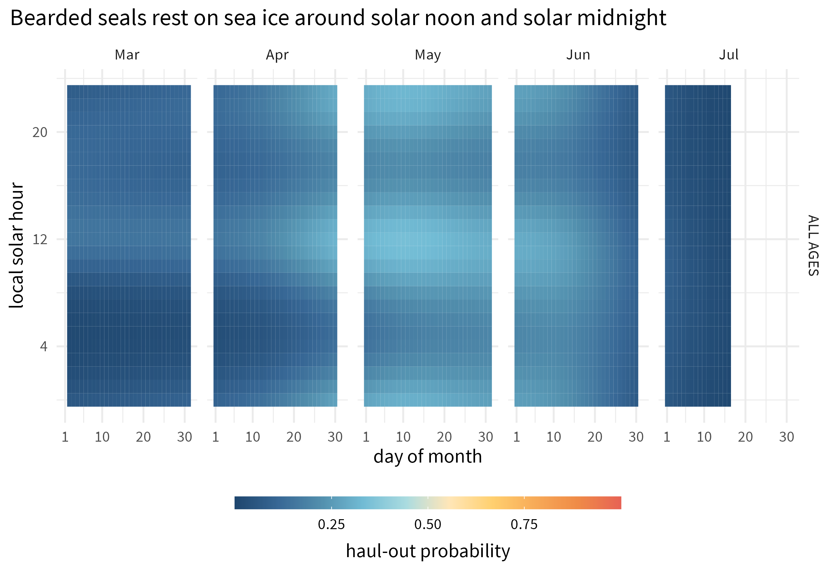

**Figure** : Predicted haul-out probability of bearded seals (all ages and sex classes) from 1 March to 15 July for all and sex classes.

When exploring the influence of weather, Bearded seal haul-out probability appears most influenced by wind ( $F_{1,42302}$ = 185.426; $p$ = <0.001) and temperature ( $F_{1,42302}$ = 14.915; $p$ = <0.001). Additionally, wind chill was also a significant influence ( $F_{1,42302}$ = 13.58; $p$ = <0.001). Any influence of barometric pressure or precipitation was less apparent.

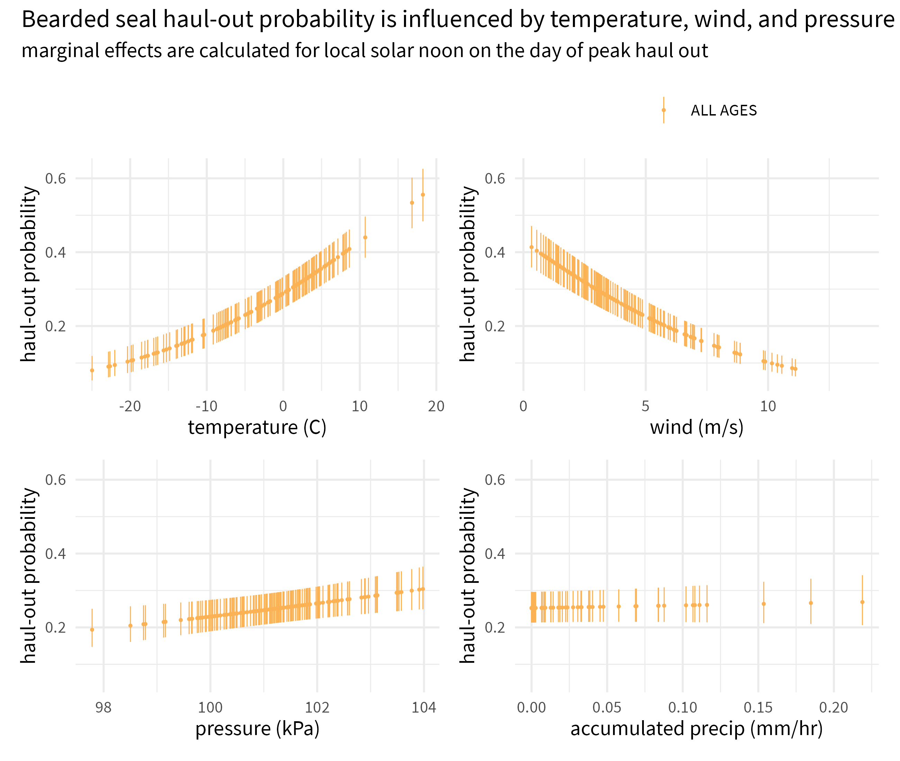

**Figure** : Marginal effects of temperature, wind, pressure, and accumulated precipitation on the predicted haul-out probability of bearded seals combined across all age and sex classifications. Hour of the day was fixed at local solar noon and day-of-year held at the day of peak haul-out for bearded seals. Transparent vertical lines represent the 95% confidence interval around the predicted haul-out probability.

## Ribbon Seals

Ribbon seals show a pattern of gradually increasing haul-out probability in April that peaks in late May for subadults and in early June for adults (Figure ). The behavior is clearly centered around local solar noon and expands to other hours later in the season as seals enter their molting period. Subadults showed an earlier start and more intense haul-out activity in April and May. The young-of-the-year records begin after weaning and the model predictions demonstrate the ontogeny of in-water activities (e.g. diving, foraging) in May. Adult females have a more protracted haul-out season compared to males, and more time spent resting in June and July. The model suggests adult male ribbon seals complete their molt by the end of June. Lastly, for adults of both sexes there is some indication for a shift to a crepuscular haul-out pattern in late June and July.

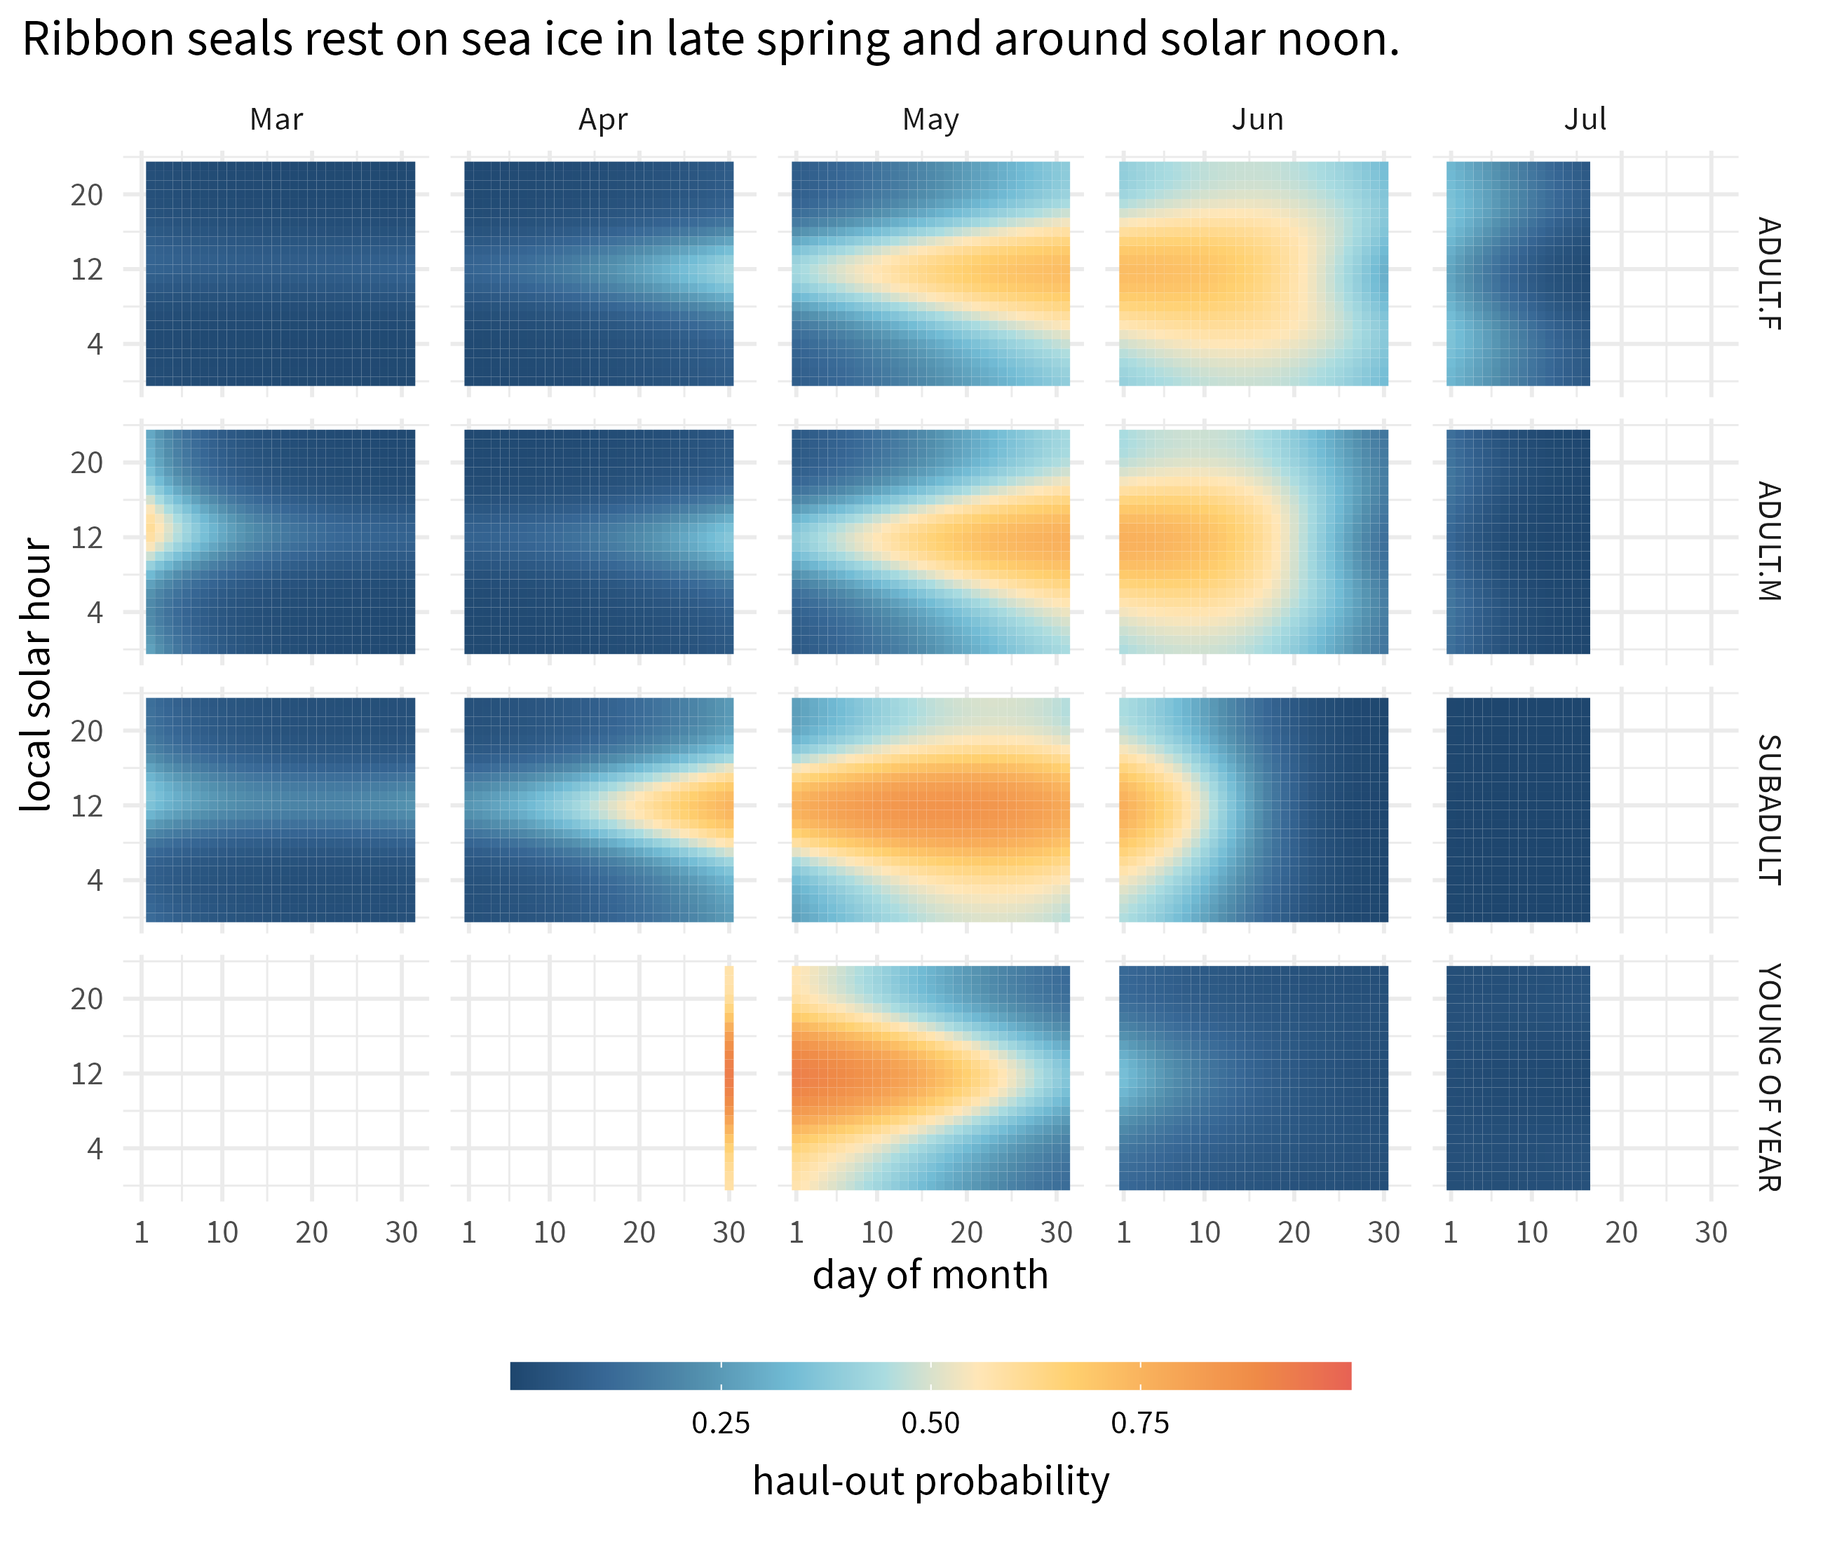

**Figure** : Predicted haul-out probability of ribbon seals from 1 March to 15 July for each age and sex class used in the model. Adult females are indicated by ‘ADULT.F’ and ‘ADULT.M’ indicates adult males. ‘SUBADULT’ and ‘YOUNG OF YEAR’ age classes include both sexes.

The haul-out probability for ribbon seals was strongly influenced by each of the weather covariates included within the model except precipitation. The impacts of temperature ( $F_{1,99593}$ = 15.688; $p$ = <0.001), wind ( $F_{1,99593}$ = 72.392; $p$ = <0.001), and barometric pressure ( $F_{1,99593}$ = 9.521; $p$ = 0.002) were especially noticeable as ribbon seals were less likely to haul out at higher winds and lower pressure values and more likely to haul out when temperatures were relatively warm. Wind chill ( $F_{1,99593}$ = 2.794; $p$ = 0.095) showed a moderately negative influence on haul-out probability. As with bearded seals, Figure presents the predicted haul-out probability of ribbon seals across the range of weather conditions encountered in the observed data. Because our ribbon seal model included age and sex class, we can visualize the different influences of weather covariates those classes. Of note, there is an indication that sub-adult ribbon seals are more likely to haul-out at lower temperatures. But, this may also be simply reflective of their tendency to haul-out earlier in the season compared to adults.

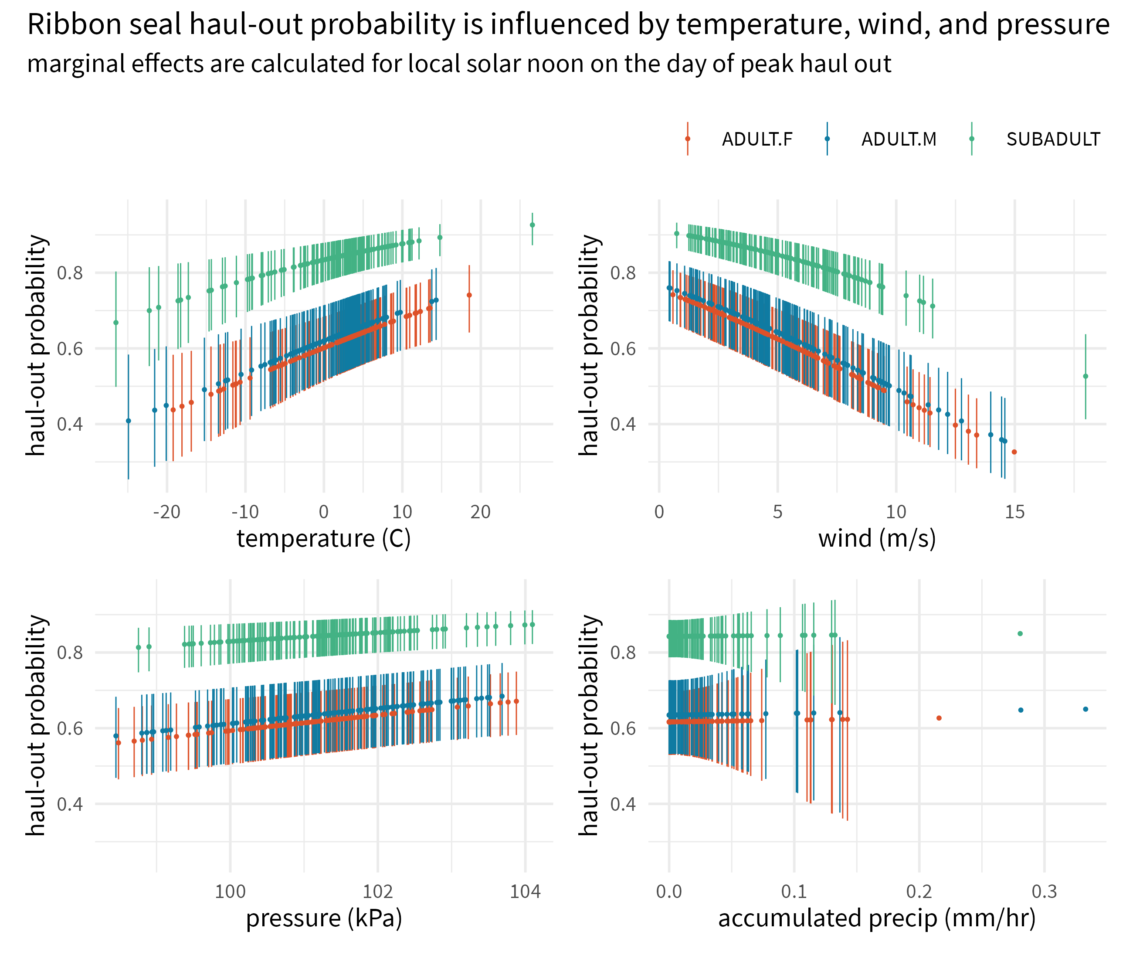

**Figure** : Marginal effects of temperature, wind, pressure, and accumulated precipitation on the predicted haul-out probability of ribbon seals within each age and sex classification. Hour of the day was fixed at local solar noon and day-of-year held at the average day of peak haul-out for ribbon seals. Transparent vertical lines represent the 95% confidence interval around the predicted haul-out probability.

## Spotted Seals

Compared to ribbon seals, spotted seals showed a longer spring haul-out season that is less intensely centered on solar noon (Figure ). Adults of both sexes spend considerable time in April, May and June hauled out. In contrast to ribbon seals, adult spotted seal males have a more protracted haul-out season compared to females, and more time out of the water in June and July (Figures and ). As with ribbon seals, the young-of-the-year records begin after weaning and the model predictions demonstrate the ontogeny of in-water activities (e.g. diving, foraging) in May.

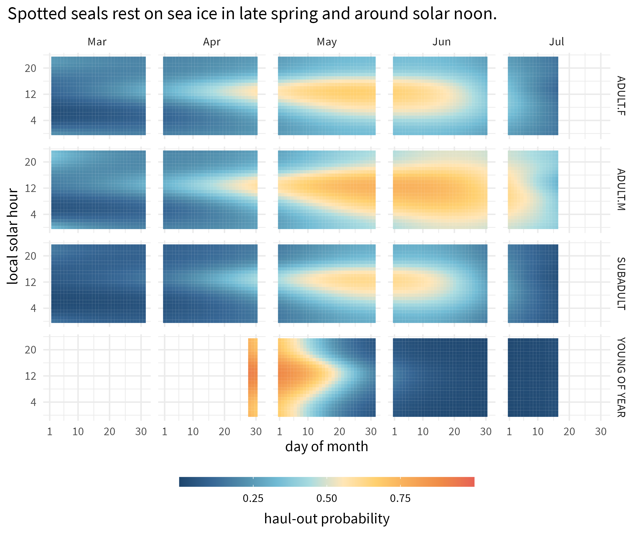

**Figure** : Predicted haul-out probability of spotted seals from 1 March to 15 July for each age and sex class used in the model. Adult females are indicated by ‘ADULT.F’ and ‘ADULT.M’ indicates adult males. ‘SUBADULT’ and ‘YOUNG OF YEAR’ age classes include both sexes.

Spotted seal haul-out behavior appears most strongly influenced by temperature ( $F_{1,108429}$ = 3.432; $p$ = 0.064) and wind ( $F_{1,108429}$ = 25.821; $p$ = <0.001) with barometric pressure having a moderate influence ( $F_{1,108429}$ = 5.05; $p$ = 0.025). Spotted seals were less likely to haul out at higher winds and more likely to be on the ice when temperatures were relatively warm. Wind chill (*temperature:wind*) and precipitation were not as influential as the other covariates. Differences in the magnitude of response between the age-sex classes are present and consistent across each of the weather covariates (Figure ). There is a consistent ranking of adult males being the most likely to haul out, followed by adult females, and, then, subadults.

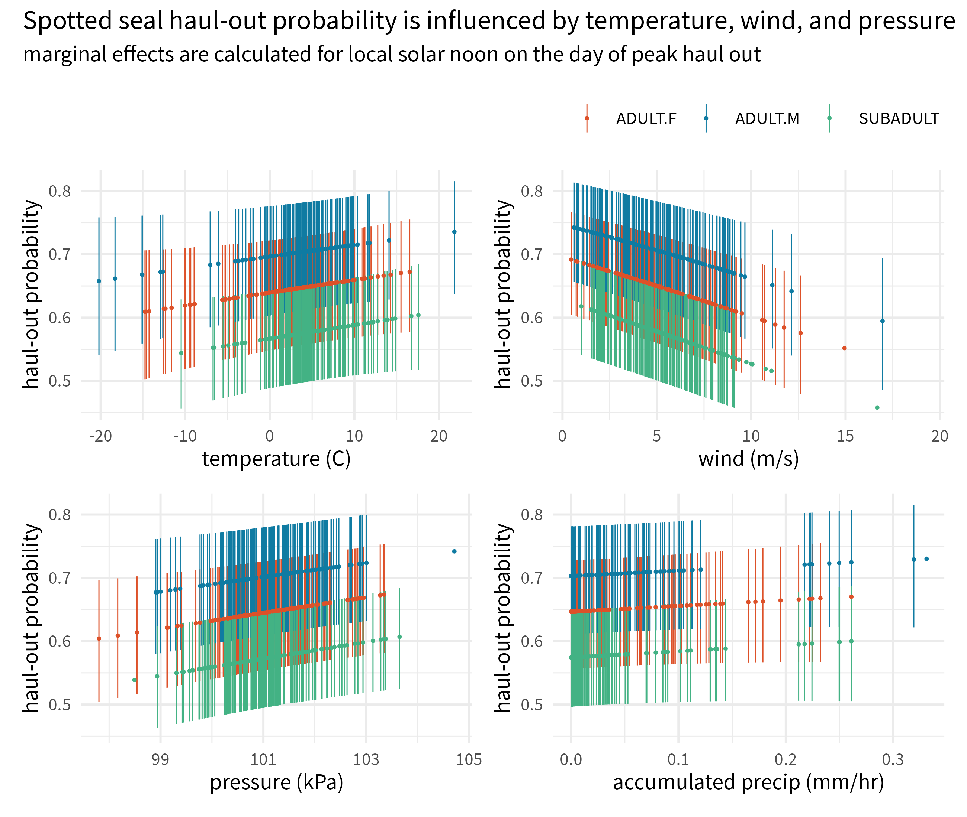

**Figure** : Marginal effects of temperature, wind, pressure, and accumulated precipitation on the predicted haul-out probability of spotted seals within each age and sex classification. Hour of the day was fixed at local solar noon and day-of-year held at the average day of peak haul-out for spotted seals. Transparent vertical lines represent the 95% confidence interval around the predicted haul-out probability.

## Annual variation in haul-out

The second set of models that included annual variation in haul-out patterns uncovered significant contributions for linear and quadratic interactions between day and year in both ribbon seals (day:year, $F_{10,99563}$ = 4.051; $p$ = <0.001; day2:year, = 4.582; $p$ = <0.001) and spotted seals (day:year, $F_{14,108387}$ = 4.732; $p$ = <0.001; day2:year, = 4.848; $p$ = <0.001). Predicted distributions of haul-out activity were largely unimodal, but varied some among and within years with respect to the timing and magnitude of haul-out peaks (Figure ). It is important to note that predicted variation in annual haul-out patterns likely reflects both process error and sampling variability. While we did remove any years where only one deployment in a species + age-sex group was present, there are still some years where the pattern shown is informed by a small number of individuals that may not represent population level processes.

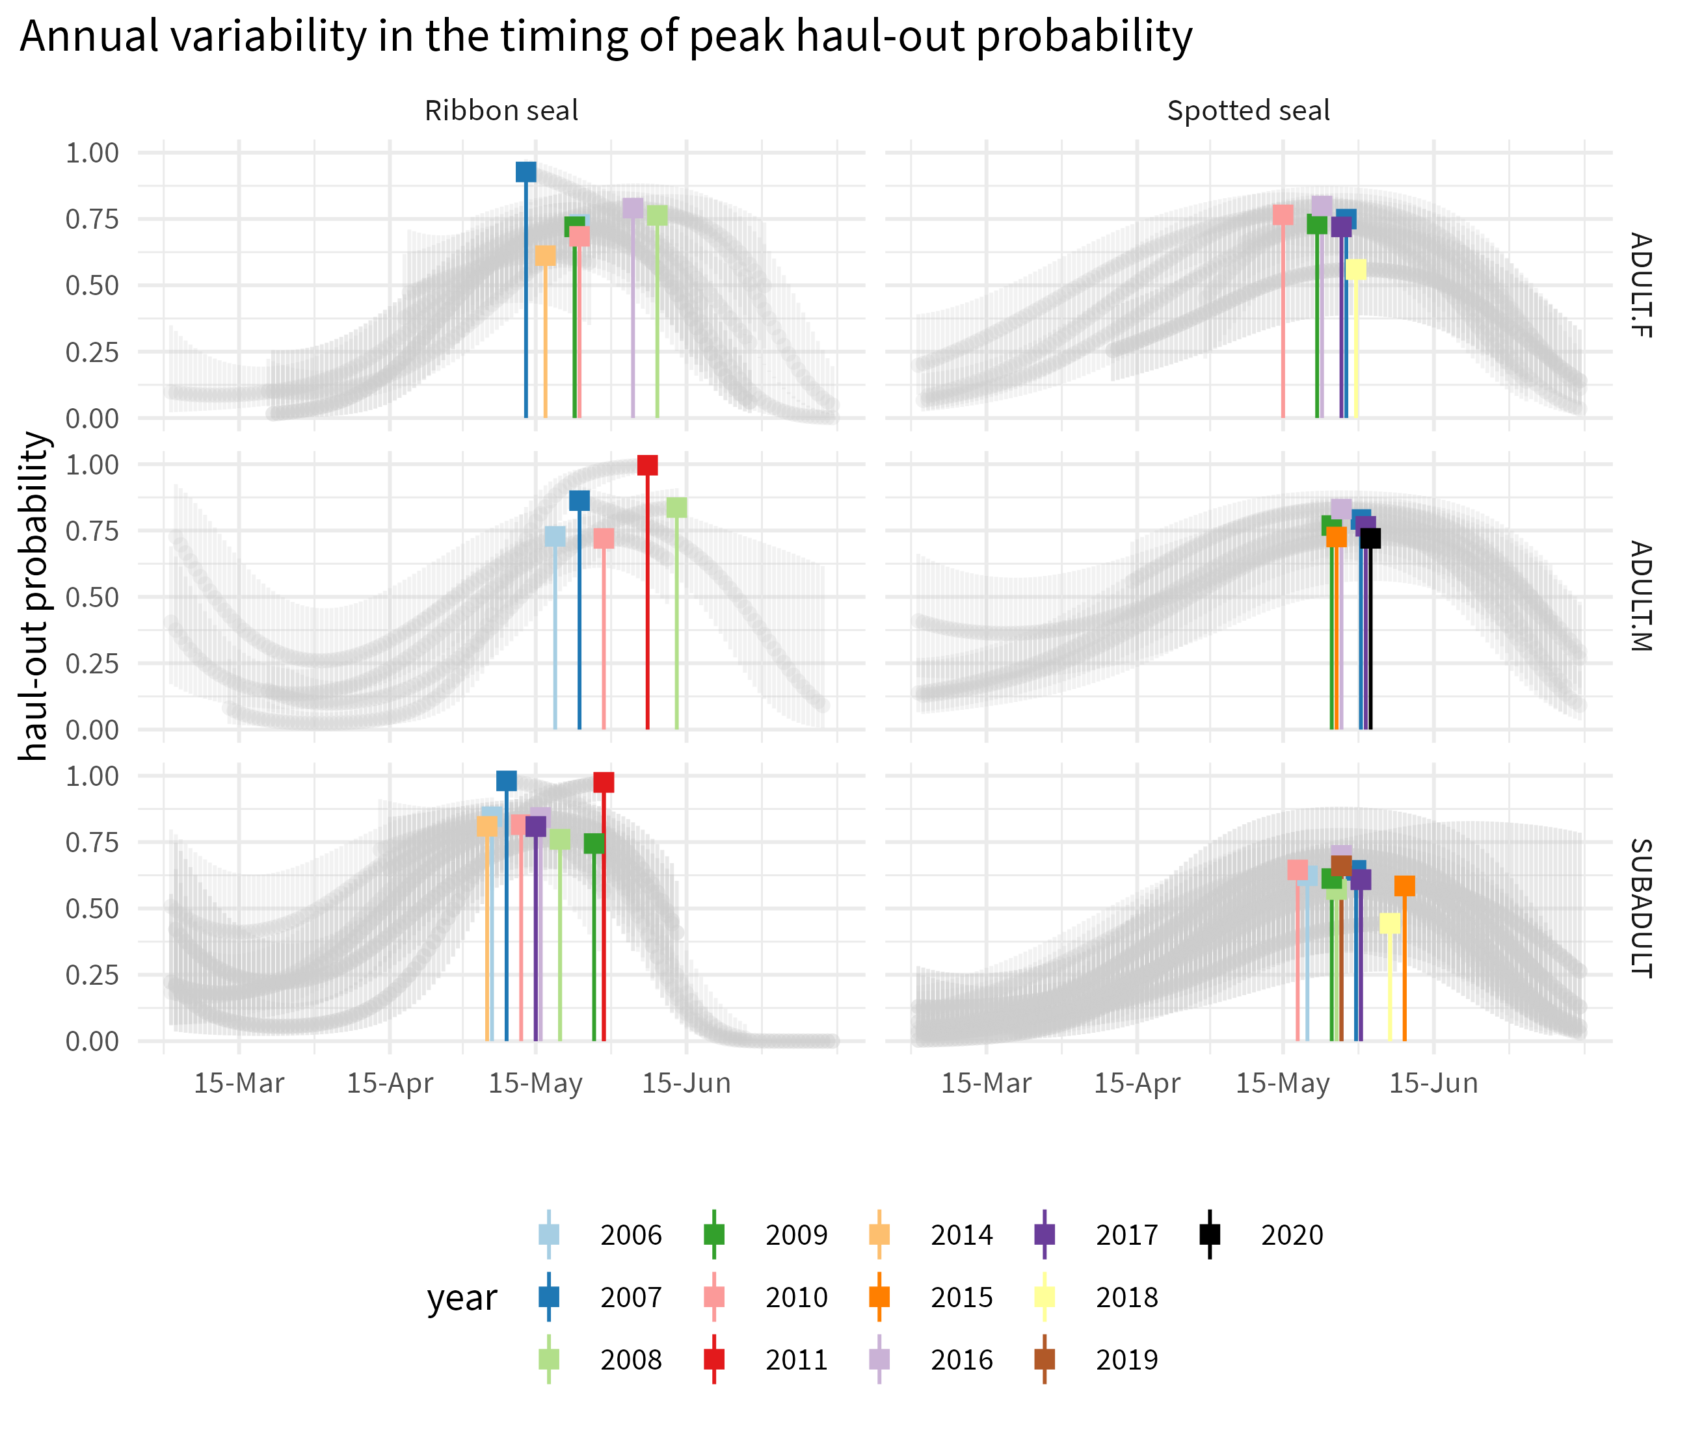

**Figure** : Annual variability in the timing of peak haul-out probability for ribbon and spotted seals across 10 years. Predictions are shown for local solar noon and under smoothed weather conditions. Only those groups (age-sex + year) that included observations from more than one seal are shown. Additionally, any groups where the underlying data started after 1 June or ended before 1 May are not included.

The timing of peak haul-out probability for ribbon and spotted seals appeared to have a limited to no relationship with the amount of yearly maximum sea ice extent. Adult female and subadult spotted seals show a negative trend line, but there is no indication that the observed trend is meaningful (spotted seal adult female: $R^{2}$ = 0.767, $p$ = 0.022; spotted seal subadults: $R^{2}$ = 0.449, $p$ = 0.034). For ribbon seals and adult male spotted seals, $p$-values were substantially larger than 0.05 (ribbon seal adult females; $R^{2}$ = 0.035, $p$ = 0.689; ribbon seal adult males: $R^{2}$ = 0.116, $p$ = 0.575; ribbon seal subadults: $R^{2}$ = 0.013, $p$ = 0.773; spotted seals adult males: $R^{2}$ = 0.107, $p$ = 0.592).

# Discussion

We modeled data from bio-loggers deployed on bearded, ribbon, and spotted seals to examine factors affecting haul-out behavior on sea ice in the Bering and Chukchi seas. Our analysis shows all three species of seal haul out progressively more through the spring and peak near mid-May to early June before declining again. This pattern aligns well with what has been previously documented and confirms our haul-out data are likely capturing population-level behavioral patterns. Seals preferentially haul out on ice shortly after solar noon, which allows seals to maximize absorption of solar radiation thought to facilitate the molting process [39]. Interestingly, bearded seals appear to have two peaks in haul-out activity within a day, one shortly after solar noon, and one centered near solar midnight. This, of course, could be an artifact of our limited sample size for bearded seal deployments across all age classes. However, a similar bi-modal pattern has been seen in ringed seals [15] and suggests that bearded and ringed seals may be operating under different constraints than ribbon and spotted seals. Bearded and ringed seals are distributed across higher latitudes and the extended daylight hours may allow more flexibility in optimizing resting periods with foraging. Other factors such as predation by polar bears (which is rare for ribbon and spotted seals in the Bering Sea) may also explain differing haul-out patterns. Bearded seals also showed a more protracted season of haul-out behavior compared to ribbon and spotted seals. This aligns with findings from Thometz et al. [40] who observed a mean molting period of 119±2 days and a relatively stable resting metabolic rate during that time. While ribbon seals were not considered in the same study, spotted and ringed seals underwent molt periods of 33±4 and 28±6 days and exhibited increased resting metabolic rates.

Unlike previous analyses of seal haul-out behavior (e.g. [36], [22]), we also investigated the influence of sex-age class on haul-out probabilities for all species except bearded seals because of low sample size. Although ribbon and spotted seals exhibited a unimodal diel haul-out pattern generally centered around local solar noon, there were key differences across species, age, and sex that match expectations given what we know of their ecological behavior. Spotted seals are known to form triads during the breeding season [41] where a female and dependent pup are accompanied on the ice by a suitor male. The male waits for the female to wean the pup and enter estrus, and fends off any other potential suitor males. Triad formation results in both males and females spending a large portion of the day hauled out on ice and a protracted spring haul-out season for both sexes. Because mating occurs in the water, females may also be less inclined to interrupt their haul-out with foraging trips while still nursing the pup. We see this reflected in the predicted haul-out behavior, with both males and females exhibiting a broad distribution of time out of the water throughout the solar day and the season.Ribbon seals are not known to form triads and our model predicts a progression of increased haul-out behavior with females starting earlier in the season than males. Notably, female ribbon seals spend a large portion of the day in the water during the pupping period, aligning with the hypothesis that ribbon seal females continue foraging while nursing. In the case of both ribbon and spotted seals, subadults are the first to begin consistent haul-out behavior and follow a typical phocid pattern where subadults molt first as they do not have any reproductive constraints.

We also investigated the influence of weather on haul-out probabilities, including wind speed, temperature, barometric pressure, precipitation, and wind chill. These have been investigated for walruses (e.g. Udevitz et al. [20]) and a few select studies of ice-associated seals [31]. Ribbon seals seemed to be the most influenced by weather, with wind, temperature, barometric pressure, and precipitation all being important components of the model. Spotted seals were most affected by wind and barometric pressure. And, for bearded seals, the model indicated wind and temperature had the greatest impact. In general, and as might be expected, seals were more likely to haul-out when daily temperatures were warmer, winds speeds were lower, barometric pressure was higher, and precipitation was lower. These weather conditions are general indicators of increased solar radiation which provides energetic benefits. Low winds and precipitation may also provide an optimal situation for predator detection. Our results highlight the importance of incorporating weather covariates when analyzing haul-out behavior and calculating availability corrections for aerial surveys.

Our models detected small deviations in the timing and magnitude of annual peaks in haul-out behavior for ribbon and spotted seals. The timing of peak haul-out activity appears to fall within a relatively narrow time window of 3-4 weeks in late May and early June. This consistency across 15 years is likely a reflection of the relationship between a critical photoperiod and the timing of important life history stages [43,44]. However, along with a critical photoperiod, ribbon and spotted seals are dependent upon the presence of sea ice for pupping and molt. We didn’t find any support in our models for a relationship between the timing of peaks in haul-out behavior and the amount of yearly maximum sea ice. This could indicate that, while the extent of spring sea ice in the Bering sea varied widely during our study period, seals were still able to locate sea ice and haul out. We should expect, however, that some minimal threshold in the spatial extent or density of sea ice will have a meaningful impact on the timing of peak haul-out behavior – if there is no sea ice, seals will not haul out. Additionally, while from an ecological perspective the haul-out behavior appears consistent, the interannual differences in timing and magnitude are large enough to have important ramifications on calculations of abundance and trend. Those ramifications will only be exacerbated if climate variability amplifies interannual differences.

Previous attempts to estimate the abundance of phocid seals from aerial survey data in the Bering and Chukchi seas (e.g. [16], [22], [17]) have used estimated haul-out probabilities to correct for the proportion of animals that are in the water and thus unavailable to be counted. Although several of these studies allowed haul-out probabilities to vary by day-of-year and time-of-day, they have not accounted for variability among years, in weather conditions, and in the age-sex class of the sample. In this paper, we have shown that there can be considerable differences in the number of seals hauled out on ice based on these factors. We recommend that future abundance analyses employ availability models that account for these factors. For instance, it is relatively straightforward to obtain weather reanalysis products for times and locations that are surveyed and to construct a relevant correction factor based on predictions of GLMPMs. The most challenging element in developing availability correction factors is with annual variability. It can be difficult to get a sufficient sample size to estimate year-specific correction factors, particularly because research teams would likely need to tag seals and conduct aerial surveys concurrently which requires considerably more personnel and money. One possible suggestion is to estimate a “shift” parameter within models for aerial survey counts that allow the peak of haul-out distributions to be adjusted earlier or later in the year based on the frequency of counts observed over time. Regardless, researchers should anticipate there being some unmodeled heterogeneity in availability probability present in abundance estimates obtained from aerial surveys. This may make trend detection difficult, as one will not know if moderate differences in abundance estimates are attributable to changes in abundance or changes in haul-out behavior.

Predictions of absolute haul-out probability in this paper were somewhat different than those previously reported for these species, especially for bearded seals. For instance, Ver Hoef et al. [17)] and Conn et al. [22] used haul-out correction factors with maximums of 0.66 for bearded seals, 0.62 for ribbon seals, and 0.54 for spotted seals, where maximums corresponded to times near solar noon in mid-late May. Applying models that ignore age, sex, and year effects, these probabilities were 0.38, 0.72, and 0.60, respectively, under the current analysis framework. Our current estimates of haul-out probability reflect increased sample sizes in terms of number of animals, but also improvements to the way data were prepared prior to analysis.

We focused this paper on haul-out behavior of bearded, ribbon, and spotted seals. Ringed seals are also present in the Bering and Chukchi seas but exhibit a unique complicating factor. Adult ringed seals build subnivean lairs in the snow on top of the sea ice, where they haul out and pup until snow melt causes their lairs to collapse [45]. Thus, the wet-dry sensor on a bio-logger could indicate that an animal is hauled out, but if it is within a lair, it is not available to be detected during an aerial survey. We hope to address availability of ringed seals using data from satellite tags, replicate survey tracks, and auxiliary information about snow depth and timing of melt in a future study.

# Author Contributions

**Josh M. London**: investigation, conceptualization, methodology, formal analysis, validation, software, writing: original draft, writing: review and editing, visualization, and data curation

**Paul B. Conn**: conceptualization, methodology, formal analysis, software, validation, writing: original draft, writing: review and editing

**Stacie K. Hardy**: investigation, data curation, methodology, validation, writing: review and editing

**Erin L. Richmond**: data curation, investigation, methodology, validation, writing: review and editing

**Jay M. Ver Hoef**: conceptualization, methodology, software, writing: review and editing

**Michael F. Cameron**: investigation, project administration, writing: review and editing

**Justin Crawford**: investigation, methodology, validation, data curation, writing: review and editing

**Lori T. Quakenbush**: investigation, methodology, supervision, project administration, writing: review and editing

**Andrew L. Von Duyke**: investigation, methodology, validation, data curation, writing: review and editing

**Peter L. Boveng**: investigation, conceptualization, supervision, project administration, writing: review and editing

# Data Availability

This manuscript was developed as a reproducible research compendium. Data and code are available on GitHub (<https://github.com/jmlondon/berchukHaulout>) and major versions archived at Zenodo (<https://doi.org/10.5281/zenodo.4638221>). Original data sources for telemetry are archived at the United States Animal Telemetry Network.

# Acknowledgements

We recognize that the species and ecosystems studied in this paper are within the traditional range of the Inpuiaq and Yupik people. And, we would like to acknowledge and thank them as the original stewards of these ecosystems. The deployment of bio-logging devices used in this study were often done in collaboration with Alaska Native seal hunters and their communities. We would like to especially acknowledge the communities of Kotzebue, Koyuk, Utqiaġvik, and Ulguniq (Wainwright) and the following individuals: James Adams, Jeff Barger, David Barr, Wendell Booth, Cyrus Harris, Nereus ‘Doc’ Harris, Grover Harris, Lee Harris, Tom Jones, Frank Garfield, Brenda Goodwin, Henry Goodwin, John Goodwin, Pearl Goodwin, Willie Goodwin, Brett Kirk, Noah Naylor, Virgil Naylor Jr., Virgil Naylor Sr., Dan Savetilik, Allen Stone, and Randy Toshavik from Kotzebue, Alaska; Merlin Henry from Koyuk, Alaska; Billy Adams, Mary-Ellen Ahmaogak, James Aiken, Tim Aiken, Sarah Coburn, Jason Herreman, Howard Kittick, Gilbert Leavitt, Isaac Leavitt, J.R. Leavitt, Enoch Oktollik, Shawn Oktollik, Stacey Osborn, Fred Rexford, Chuck Schaeffer, Ross Schaeffer, Bob Shears, and Joe Skin from the North Slope Borough, Alaska;

We are grateful for the assistance in catching and sampling seals by James Bailey, Michelle Barbieri, John Bengtson, Gavin Brady, Vladamir Burkanov, Cynthia Christman, Shawn Dahle, Rob Delong, Stacy DiRocco, Deb Fauquier, Shannon Fitzgerald, Kathy Frost, Scott Gende, Tracey Goldstein, Jeff Harris, Markus Horning, John Jansen, Shawn Johnson, Charles Littnan, Lloyd Lowry, Erin Moreland, Mark Nelson, Lorrie Rea, Gay Sheffield, Brent Stewart, and Dave Withrow. We also appreciate the commitment to science and safety by all officers and crew of the NOAA Ship Oscar Dyson, the NOAA Ship MacArthur II, and the RV Thomas G. Thompson.

Telemetry data from the Alaska Department of Fish and Game (ADFG) and the North Slope Borough Department of Wildlife Management (NSB) were important contributions to the findings presented here. Both agencies collaborate closely with Alaska Native communities and the contributions of local hunters to the successful capture, deployment, and understanding of seal ecology are invaluable. Deployments in the western Bering Sea were done in collaboration with Russian colleagues and North Pacific Wildlife.

The findings and conclusions in the paper are those of the author(s) and do not necessarily represent the views of the National Marine Fisheries Service, NOAA. Any use of trade, product, or firm names does not imply an endorsement by the U.S. Government. Funding for this study was provided by the U.S. National Oceanic and Atmospheric Administration. The field work was conducted under the authority of Marine Mammal Protection Act Research Permits Nos. 782-1676, 782-1765, 15126, and 19309 issued by the National Marine Fisheries Service, and Letters of Assurance of Compliance with Animal Welfare Act regulations, Nos. A/NW 2010-3 and A/NW 2016-1 from the Alaska Fisheries Science Center/Northwest Fisheries Science Center Institutional Animal Care and Use Committee (IACUC). ). Funding to ADFG for tagging seals was provided by the Bureau of Ocean Energy Management (No. M13PC0015) and the Office of Naval Research (No. N00014-16-1-3019). ADFG and NSB field work was covered by Research Permits Nos. 358-1585, 358-1787, 15324, and 20466 and by ADF&G IACUC permits Nos. 06-16, 09-21, 2014-03, 2015-25, 2016-23, 0027-2017-27, 0027-2018-29, 0027-2019-041.

# References

1. Kwok R. 2018 Arctic sea ice thickness, volume, and multiyear ice coverage: losses and coupled variability (1958–2018). *Environ. Res. Lett.* **13**, 105005. (doi:[10.1088/1748-9326/aae3ec](https://doi.org/10.1088/1748-9326/aae3ec))

2. Meier WN *et al.* 2014 Arctic sea ice in transformation: A review of recent observed changes and impacts on biology and human activity. *Reviews of Geophysics* **52**, 185–217.

3. Overland JE. 2021 Rare events in the Arctic. *Climatic Change* **168**, 27. (doi:[10.1007/s10584-021-03238-2](https://doi.org/10.1007/s10584-021-03238-2))

4. Wang M, Yang Q, Overland J, Stabeno P. 2017 Sea-ice cover timing in the Pacific Arctic: The present and projections to mid-century by selected CMIP5 models. *Deep Sea Research Part II: Topical Studies in Oceanography* (doi:[10.1016/j.dsr2.2017.11.017](https://doi.org/10.1016/j.dsr2.2017.11.017))

5. Huntington HP *et al.* 2020 Evidence suggests potential transformation of the Pacific Arctic ecosystem is underway. *Nature Climate Change*, 342–348. (doi:[10.1038/s41558-020-0695-2](https://doi.org/10.1038/s41558-020-0695-2))

6. Boveng PL, Bengtson JL, Buckley TW, Cameron MF, Dahle SP, Kelly BP, Megrey BA, Overland JE, Williamson NJ. 2009 Status review of the spotted seal (*Phoca largha*). *U.S. Dep. Commer., NOAA Tech. Memo.* **NMFS-AFSC-200**, 153.

7. Boveng PL *et al.* 2013 Status review of the ribbon seal (*Histriophoca fasciata*). *U.S. Dep. Commer., NOAA Tech. Memo.* **NMFS-AFSC-255**, 174.

8. Cameron MF *et al.* 2010 Status review of the bearded seal (*Erignathus barbatus*). *U.S. Dep. Commer., NOAA Tech. Memo.* **NMFS-AFSC-211**, 246.

9. Kelly BP *et al.* 2010 Status review of the ringed seal (*Phoca hispida*). *U.S. Dep. Commer., NOAA Tech. Memo.* **NMFS-AFSC-212**, 250.

10. Crawford JA, Quakenbush LT, Citta JJ. 2015 A comparison of ringed and bearded seal diet, condition and productivity between historical (1975-1984) and recent (2003-2012) periods in the Alaskan Bering and Chukchi seas. *Prog Oceanogr* **136**, 133–150. (doi:[10.1016/j.pocean.2015.05.011](https://doi.org/10.1016/j.pocean.2015.05.011))

11. Harwood LA, Smith TG, Alikamik J, Alikamik E, Lea EV, Stirling I, Wright H, Melling H, Zhu X. 2020 Long-term, harvest-based monitoring of ringed seal body condition and reproduction in Canada’s western arctic: an update through 2019. *Arctic* **73**, 206–220. (doi:[10.14430/arctic70428](https://doi.org/10.14430/arctic70428))

12. Boveng P, Lowry L. 2018 Ribbon seal (*Histriophoca fasciata*). In *Encyclopedia of Marine Mammals: Third Edition* (eds Bernd Würsig, J. G. M. Thewissen, Kit Kovacs), pp. 811–813. London: Academic Press.

13. Frost KJ, Burns JJ. 2018 Spotted Seal: Phoca largha. In *Encyclopedia of Marine Mammals (Third Edition)* (eds B Würsig, JGM Thewissen, KM Kovacs), pp. 928–931. Academic Press. (doi:[10.1016/B978-0-12-804327-1.00244-2](https://doi.org/10.1016/B978-0-12-804327-1.00244-2))

14. Bengtson JL, Cameron MF. 2004 Seasonal haulout patterns of crabeater seals (*Lobodon carcinophaga*). *Polar Biology* **27**, 344–349. (doi:[DOI 10.1007/s00300-004-0597-1](https://doi.org/DOI 10.1007/s00300-004-0597-1))

15. Von Duyke AL, Douglas DC, Herreman JK, Crawford JA. 2020 Ringed seal (*Pusa hispida*) seasonal movements, diving, and haul-out behavior in the Beaufort, Chukchi, and Bering Seas (2011–2017). *Ecology and Evolution* **00**, 1–22. (doi:[10.1002/ece3.6302](https://doi.org/10.1002/ece3.6302))

16. Bengtson JL, Hiruki-Raring LM, Simpkins MA, Boveng PL. 2005 Ringed and bearded seal densities in the eastern Chukchi Sea, 1999-2000. *Polar Biology* **28**, 833–845.

17. Ver Hoef JM, Cameron MF, Boveng PL, London JM, Moreland EE. 2014 A spatial hierarchical model for abundance of three ice-associated seal species in the eastern Bering Sea. *Statistical Methodology* **17**, 46–66. (doi:<http://dx.doi.org/10.1016/j.stamet.2013.03.001>)

18. Olnes J, Crawford J, Citta JJ, Druckenmiller ML, Von Duyke AL, Quakenbush L. 2020 Movement, diving, and haul-out behaviors of juvenile bearded seals in the Bering, Chukchi and Beaufort seas, 2014–2018. *Polar Biology* (doi:[10.1007/s00300-020-02710-6](https://doi.org/10.1007/s00300-020-02710-6))

19. Reder S, Lydersen C, Arnold W, Kovacs KM. 2003 Haulout behaviour of High Arctic harbour seals (*Phoca vitulina vitulina*) in Svalbard, Norway. *Polar Biology* **27**, 6–16.

20. Udevitz MS, Jay CV, Fischback AS, Garlich-Miller JL. 2009 Modeling haul-out behavior of walruses in Bering Sea ice. *Can. J. Zool* **87**, 1111–1128. (doi:[10.1139/Z09-098](https://doi.org/10.1139/Z09-098))

21. Southwell CJ, Paxton CGM, Borchers DL, Boveng PL, Nordøy ES, Blix AS, De La Mare WK. 2008 Estimating population status under conditions of uncertainty: the Ross seal in East Antarctica. *Antarctic Science* **20**, 123–133.

22. Conn Paul B, Ver Hoef Jay M, McClintock Brett T, Moreland Erin E, London Josh M, Cameron Michael F, Dahle Shawn P, Boveng Peter L. 2014 Estimating multispecies abundance using automated detection systems: ice-associated seals in the Bering Sea. *Methods in Ecology and Evolution* **5**, 1280–1293. (doi:[10.1111/2041-210X.12127](https://doi.org/10.1111/2041-210X.12127))

23. Burns JJ. 1969 Marine mammal report. *Volume X, Project W-14-R-3 & W-17-1, Work Plan F, Job No. 3*, 25.

24. Burns JJ, Frost KJ. 1983 The natural history and ecology of the bearded seal, *Erignathus barbatus*. In *Environmental Assessment of the Alaskan Continental Shelf. Final Reports of Principal Investigators. Volume 19. December 1983*, pp. 311–392. Juneau, AK: U.S. Department of Commerce, NOAA, and U.S. Department of the Interior.

25. McLaren IA. 1958 Some aspects of growth and reproduction of the bearded seal, *Erignathus barbartus* (Erxleben). *J. Fish. Res. Bd. Can.* **15**, 219–227.

26. Conn PB, Johnson DS, London JM, Boveng PL. 2012 Accounting for missing data when assessing availability in animal population surveys: an application to ice-associated seals in the Bering Sea. *Methods in Ecology and Evolution*, 1039–1046.

27. Devin S. Johnson, Joshua M. London, Mary-Anne Lea, John Durban. 2008 Continuous-time correlated random walk model for animal telemetry data. *Ecology* **89**, 1208–1215.

28. Lopez R, Malardé JP, Royer F, Gaspar P. 2013 Improving Argos Doppler location using multiple-model Kalman filtering. *Geoscience and Remote Sensing, IEEE Transactions on* **PP**, 1–12. (doi:[10.1109/tgrs.2013.2284293](https://doi.org/10.1109/tgrs.2013.2284293))

29. Perpiñán O. 2012 solaR: Solar Radiation and Photovoltaic Systems with R. *Journal of Statistical Software* **50**, 1–32.

30. R Core Team. 2021 R: A language and environment for statistical computing.

31. Perry EA, Stenson GB, Buren AD. 2017 Attendance and nursing patterns of harp seals in the harsh environment of the northwest Atlantic. *Polar Biol* **40**, 151–160. (doi:[10.1007/s00300-016-1938-6](https://doi.org/10.1007/s00300-016-1938-6))

32. Mesinger F *et al.* 2006 North American regional reanalysis. *Bulletin of the American Meteorological Society* **87**, 343–360.

33. Crawford JA, Frost KJ, Quakenbush LT, Whiting A. 2019 Seasonal and diel differences in dive and haul-out behavior of adult and subadult ringed seals (*Pusa hispida*) in the Bering and Chukchi seas. *Polar Biology* **42**, 65–80. (doi:[10.1007/s00300-018-2399-x](https://doi.org/10.1007/s00300-018-2399-x))

34. Cavalieri DJ, Parkinson CL, Gloersen P, Zwally H. 1996, updated yearlySea ice concentrations from Nimbus-7 SMMR and DMSP SSM/I-SSMIS passive microwave data [indicate subset used]. Boulder, Colorado USA: NASA National Snow and Ice Data Center Distributed Active Archive Center.

35. Betts MG, Diamond AW, Forbes GJ, Villard M-A, Gunn JS. 2006 The importance of spatial autocorrelation, extent and resolution in predicting forest bird occurrence. *Ecological Modelling* **191**, 197–224. (doi:[10.1016/j.ecolmodel.2005.04.027](https://doi.org/10.1016/j.ecolmodel.2005.04.027))

36. Ver Hoef JM, London JM, Boveng PL. 2010 Fast computing of some generalized linear mixed pseudo-models with temporal autocorrelation. *Computational Statistics* **25**, 39–55. (doi:[10.1007/s00180-009-0160-1](https://doi.org/10.1007/s00180-009-0160-1))

37. London JM, Ver Hoef JM, Jeffries SJ, Lance MM, Boveng PL. 2012 Haul-out behavior of harbor seals (*Phoca vitulina*) in Hood Canal, Washington. *PLoS ONE* **7**, e38180. (doi:[10.1371/journal.pone.0038180](https://doi.org/10.1371/journal.pone.0038180))

38. Ten Eyck P, Cavanaugh JE. 2018 An Alternate Approach to Pseudo-Likelihood Model Selection in the Generalized Linear Mixed Modeling Framework. *Sankhya B* **80**, 98–122. (doi:[10.1007/s13571-017-0130-5](https://doi.org/10.1007/s13571-017-0130-5))

39. Feltz ET, Fay FH. 1966 Thermal requirements in vitro of epidermal cells from seals. *Cryobiology* **3**, 261–264.

40. Thometz NM, Hermann-Sorensen H, Russell B, Rosen DAS, Reichmuth C. 2021 Molting strategies of Arctic seals drive annual patterns in metabolism. *Conservation Physiology* **9**. (doi:[10.1093/conphys/coaa112](https://doi.org/10.1093/conphys/coaa112))

41. Burns JJ. 1973 Ice breeding spotted seal (*Phoca vitulina largha*).

42. Hamilton V, Evans K. 8// 2018Establishing growth chronologies from marine mammal teeth: a method applicable across species. *Journal of Experimental Marine Biology and Ecology* **505**, 24–34. (doi:<https://doi.org/10.1016/j.jembe.2018.04.006>)

43. Bronson FH. 2009 Climate change and seasonal reproduction in mammals. *Philos T R Soc B* **364**, 3331–3340. (doi:[10.1098/rstb.2009.0140](https://doi.org/10.1098/rstb.2009.0140))

44. Temte JL. 1994 Photoperiod control of birth timing in the harbour seal (*Phoca vitulina*). *J. Zool.* **233**, 369–384.

45. Kelly BP. 1990 Labrador retrievers and other high technologies in the investigation of ringed seal ecology: Purdue University Biology Graduate Student Seminar.